# Natural Language Processing Specialization

## Course 2 – Natural Language Processing with Probabilistic Models

### Week 1 – Autocorrect

#### Objective of this Week:

Learn about autocorrect, minimum edit distance, and dynamic programming, then build your own spellchecker to correct misspelled words!

Lecture: **Autocorrect and Minimum Edit Distance**

**Week 2 – Part of Speech Tagging**

Part of Speech Tagging (POS) is the process of assigning a part of speech to a word. By doing so, you will learn the following:

Markov Chains

Hidden Markov Models

Viterbi algorithm

Applications of POS tagging:

1. Identifying named entities
2. Speech recognition
3. Co-reference Resolution

#### Markov Chains

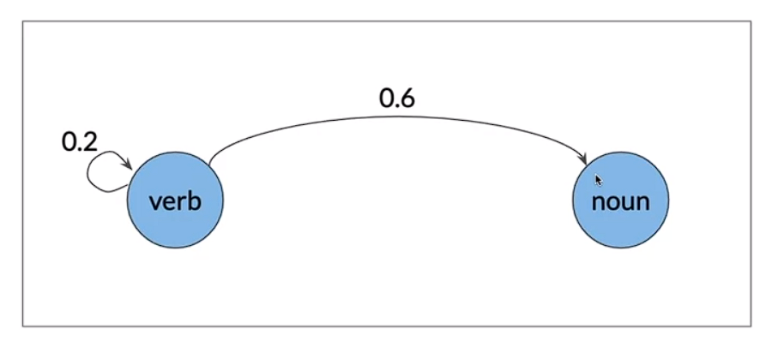

Markov Chains are a type of stochastic model that describes a sequence of possible events. To get the probability of each event, it needs only the states of the previous events. The word stochastic just means random or randomness.

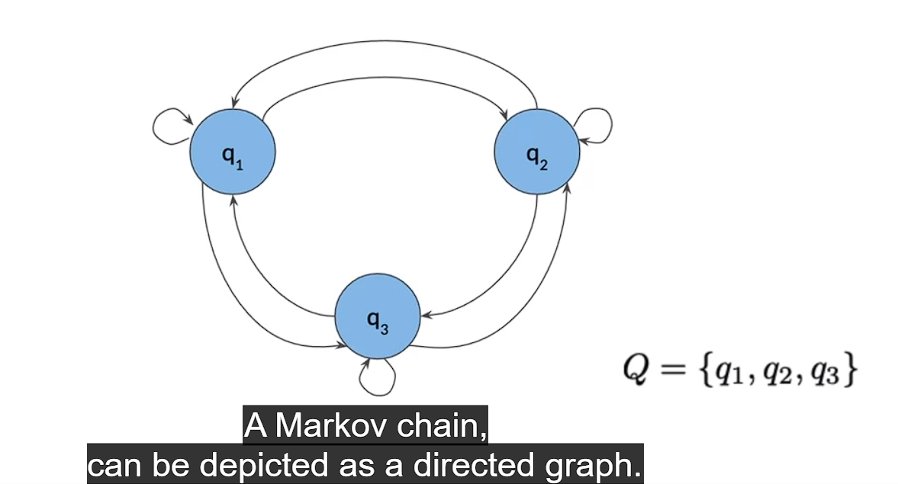

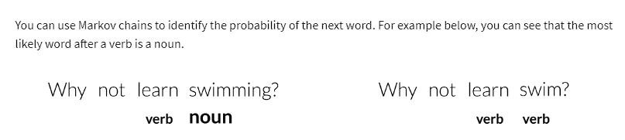

#### Markov Chains and POS Tags

Transition Probabilities tell you about the chances of going from one POS to another.

To help identify the parts of speech for every word, you need to build a transition matrix that gives you the probabilities from one state to another.

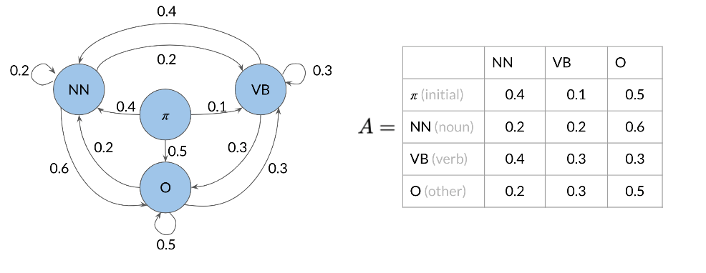

Markov property. Which states that the probability of the next event only depends on the current event. The Markov property helps keep the model simple. By saying, all you need to determine the next state is the current states. It doesn't need information from any of the previous states.

#### Hidden Markov Models

The transition probabilities allowed you to identify the transition probability from one POS to another. In hidden markov models you make use of emission probabilities that give you the probability to go from one state (POS tag) to a specific word.

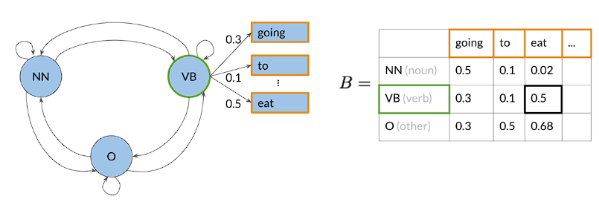

This emission matrix B, will be used with transition matrix A, to help you identify the part of speech of a word in a sentence. To populate the matrix B, you can just have a labelled dataset and compute the probabilities of going from a POS to each word in your vocabulary.

#### Calculating Probabilities

A visual representation of how to calculate the probabilities:

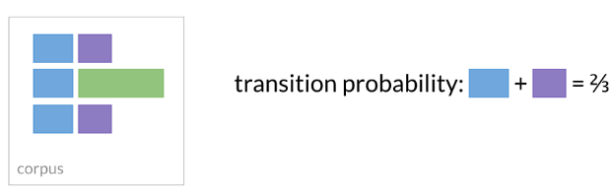

In the transition matrix we will count the number of times tag t(i-1), t(i) show up near each other and divide by the total number of times t(i-1) shows up (which is the same as the number of times it shows up followed by anything else).

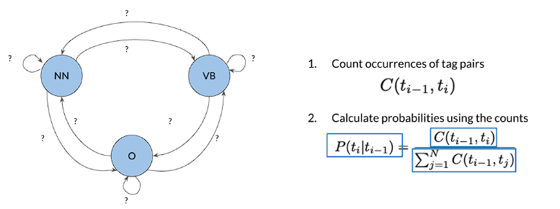

Here, C (t(i-1), t(i)) is the count of times tag t(i-1) shows up before tag i.

#### Populating the Transition Matrix

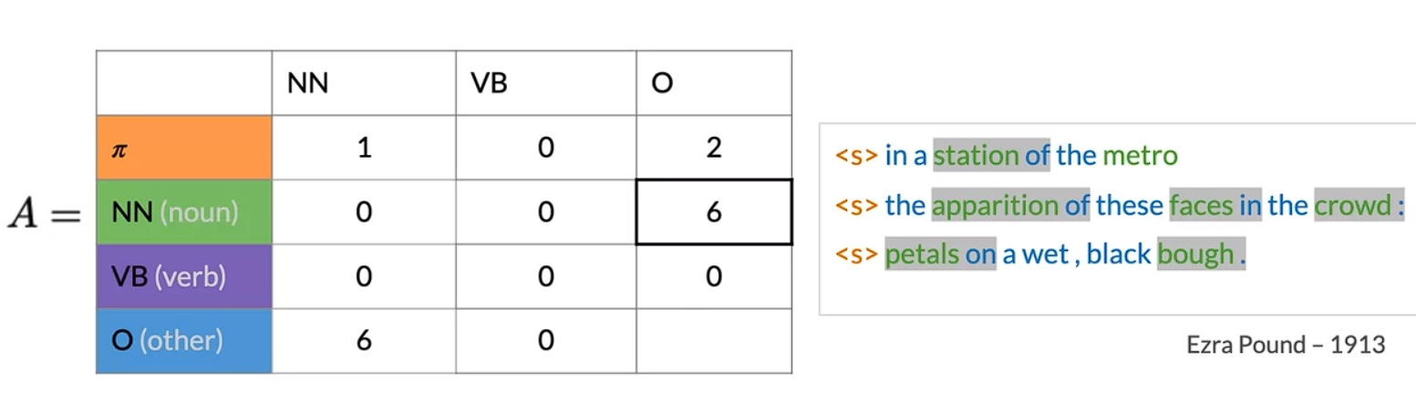

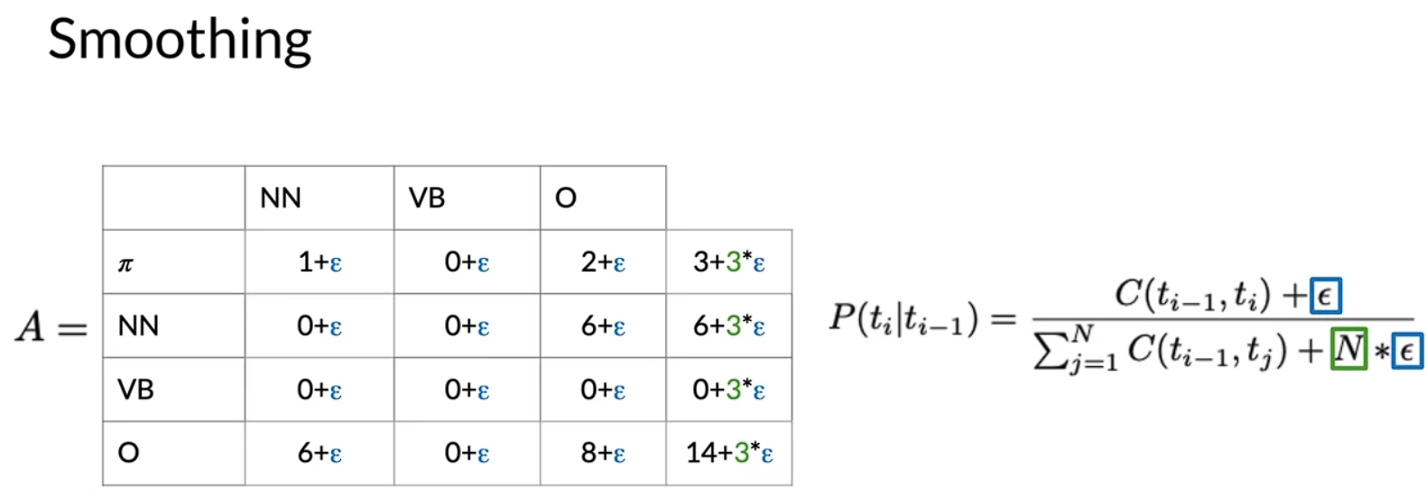

Note: **One more thing before you go, and a real-world example, you might not want to apply smoothing to the initial probabilities in the first row of the transition matrix. That's because if you apply smoothing to that row by adding a small value to possibly zeroed valued entries. You'll effectively allow a sentence to start with any parts of speech tag, including punctuation.**

#### Populating the Emission Matrix

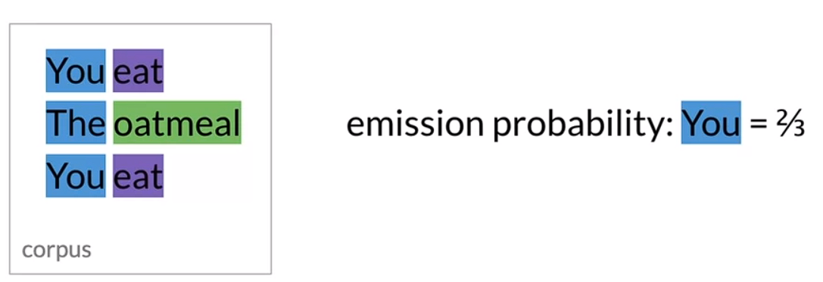

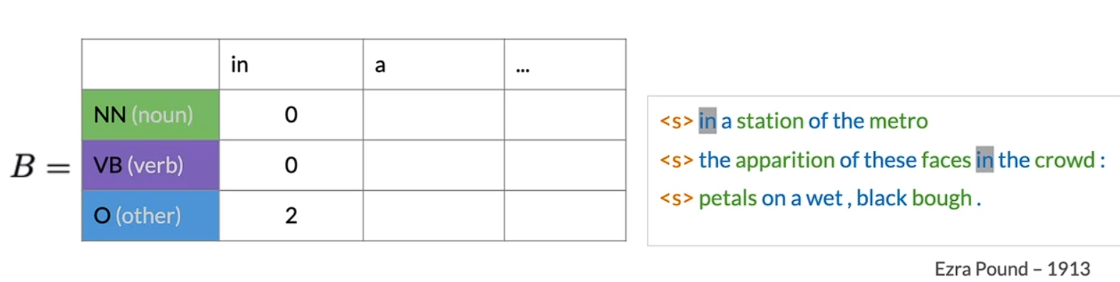

Formula for Smoothing the Emission Matrix:

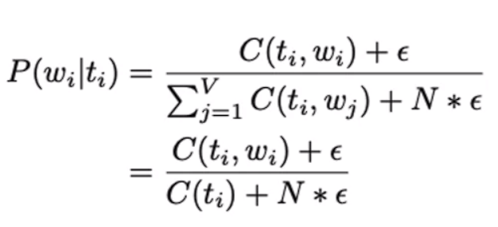

Where, C(t(i), w(i)), is the count associated with how many times the tag t(i) is associated with the word w(i). The epsilon above is the smoothing parameter.

Alphabetical list of part-of-speech tags used in the Penn Treebank Project:

|  |  |  |
| --- | --- | --- |
| No. | Tag | Description |
| 1. | CC | Coordinating conjunction |
| 2. | CD | Cardinal number |
| 3. | DT | Determiner |
| 4. | EX | Existential there |
| 5. | FW | Foreign word |
| 6. | IN | Preposition or subordinating conjunction |
| 7. | JJ | Adjective |
| 8. | JJR | Adjective, comparative |
| 9. | JJS | Adjective, superlative |
| 10. | LS | List item marker |
| 11. | MD | Modal |
| 12. | NN | Noun, singular or mass |
| 13. | NNS | Noun, plural |
| 14. | NNP | Proper noun, singular |
| 15. | NNPS | Proper noun, plural |
| 16. | PDT | Predeterminer |
| 17. | POS | Possessive ending |
| 18. | PRP | Personal pronoun |
| 19. | PRP$ | Possessive pronoun |
| 20. | RB | Adverb |
| 21. | RBR | Adverb, comparative |
| 22. | RBS | Adverb, superlative |
| 23. | RP | Particle |
| 24. | SYM | Symbol |
| 25. | TO | to |
| 26. | UH | Interjection |
| 27. | VB | Verb, base form |
| 28. | VBD | Verb, past tense |
| 29. | VBG | Verb, gerund or present participle |
| 30. | VBN | Verb, past participle |
| 31. | VBP | Verb, non-3rd person singular present |
| 32. | VBZ | Verb, 3rd person singular present |
| 33. | WDT | Wh-determiner |
| 34. | WP | Wh-pronoun |
| 35. | WP$ | Possessive wh-pronoun |
| 36. | WRB | Wh-adverb |

#### Viterbi Algorithm

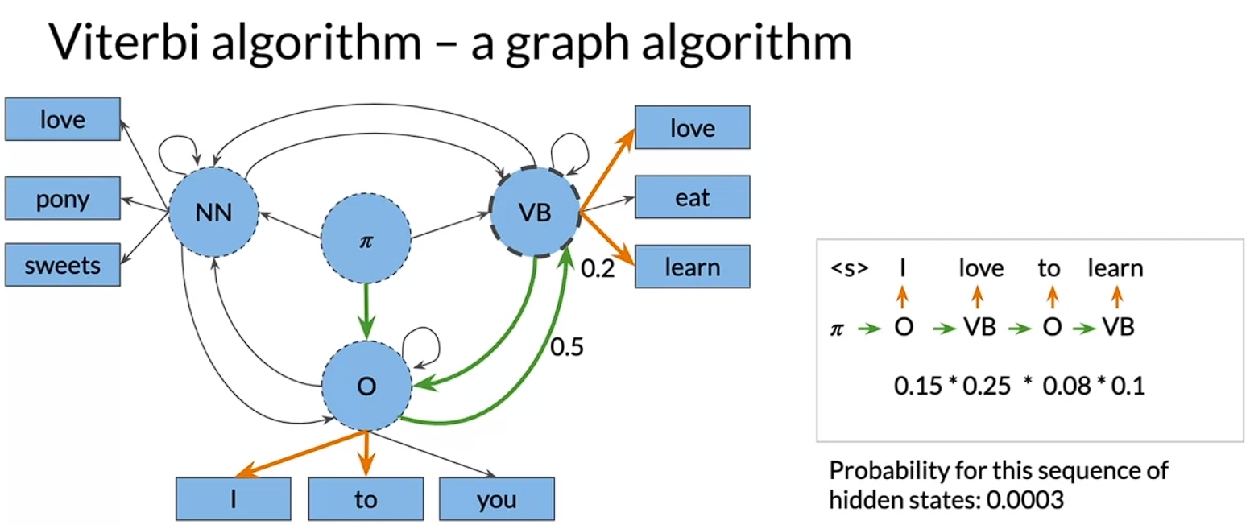

The Viterbi algorithm actually computes several such paths at the same time in order to find the most likely sequence of hidden states. It uses the matrix representation of the hidden Markov model.

Three steps:

1. Initialization
2. Forward Pass
3. Backward Pass

#### Viterbi: Initialization

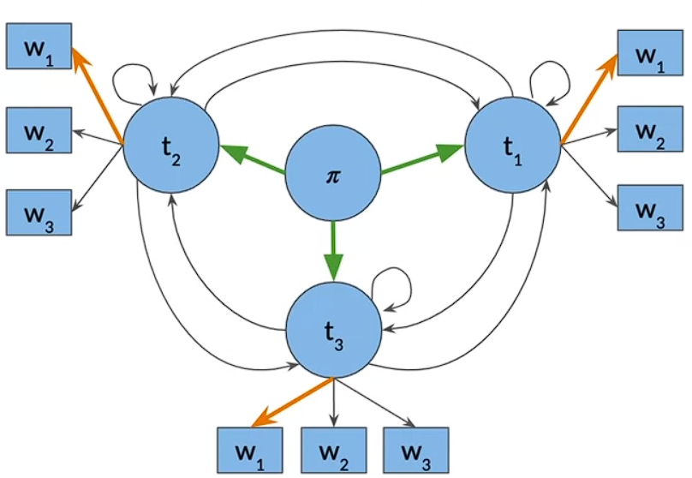

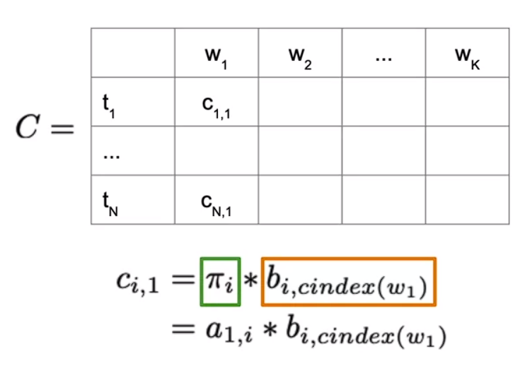

The first column of C represents probability of the transitions from the start states Pi in the graph to the first tag t_i and word w_1, meaning we're trying to go from tag 1 to the word w_1. The first column entries, c_1,1, are the products of the transition probabilities of the initial states and their respective emission probabilities.

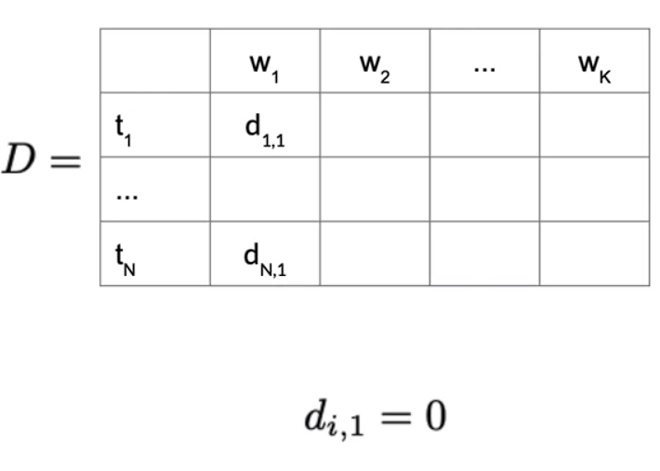

In the D matrix, you store the labels that represent the different states you're traversing when finding the most likely sequence of parts of speech tags for the given sequence of words, w_1, all the way to w_k. In the first column, you simply set all entries to zero as there are no preceding parts of speech tags we have traversed.

#### Viterbi: Forward Pass

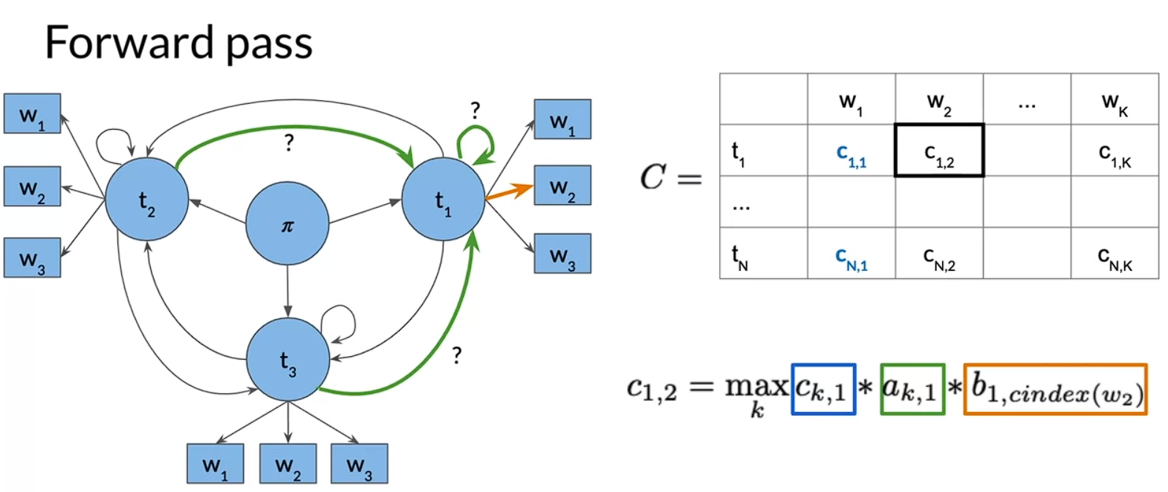

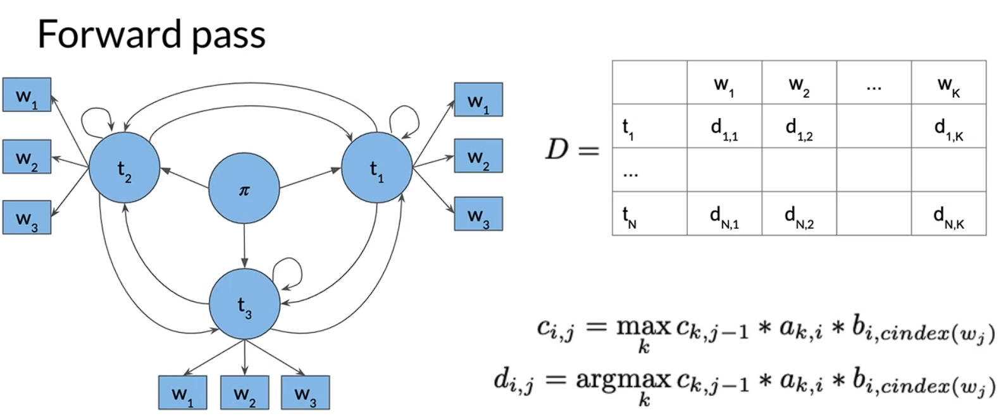

#### Viterbi: Backward Pass

Example: four tags and five words:

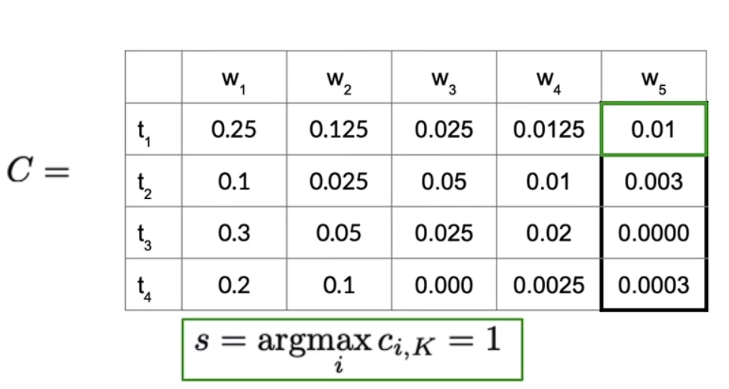

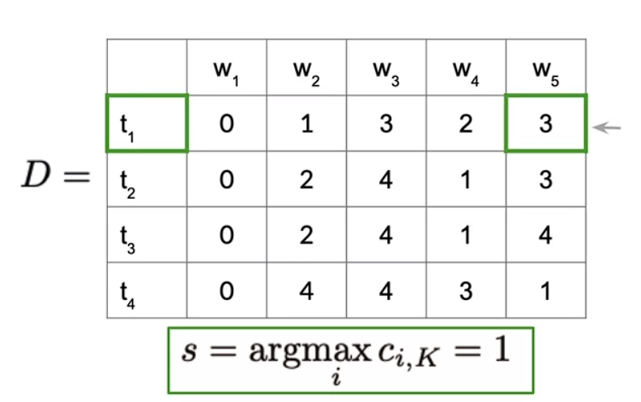

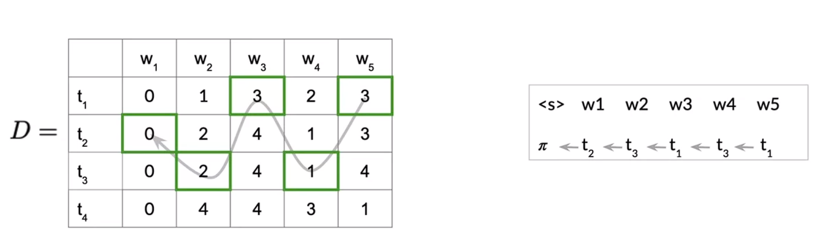

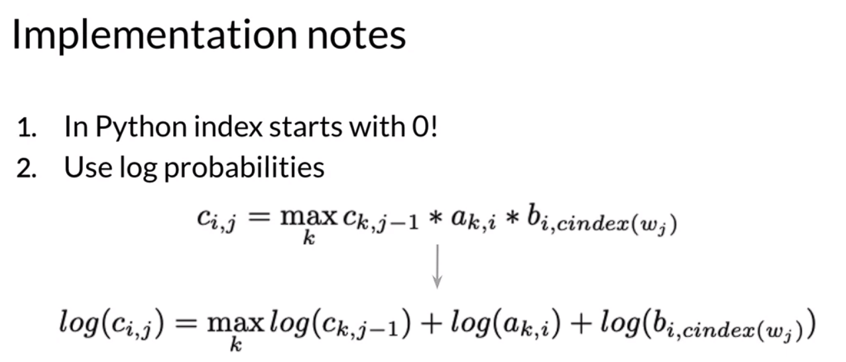

## Week 2: Autocomplete and Language Models

Objective: Learn about how N-gram language models work by calculating sequence probabilities, then build you own autocomplete language model using a text corpus from Twitter.

#### N-Grams:

Objective of this week:

* Create Language Model (LM) from text corpus to
  + Estimate probability of word sequences
  + Estimate probability of a word following a sequence of words
* Apply this concept to auto-complete a sentence with most likely suggestions

Other Applications of Language Models:

* Speech Recognition
* Spelling Correction
* Augmentative Communication – Predict most likely word from menu for people unable to physically talk or sign.

**Learning Objective**

1. Process text corpus to N-gram language model
2. Out of vocabulary words
3. Smoothing for previously unseen N-grams
4. Language model evaluation

#### N-gram and Probabilities

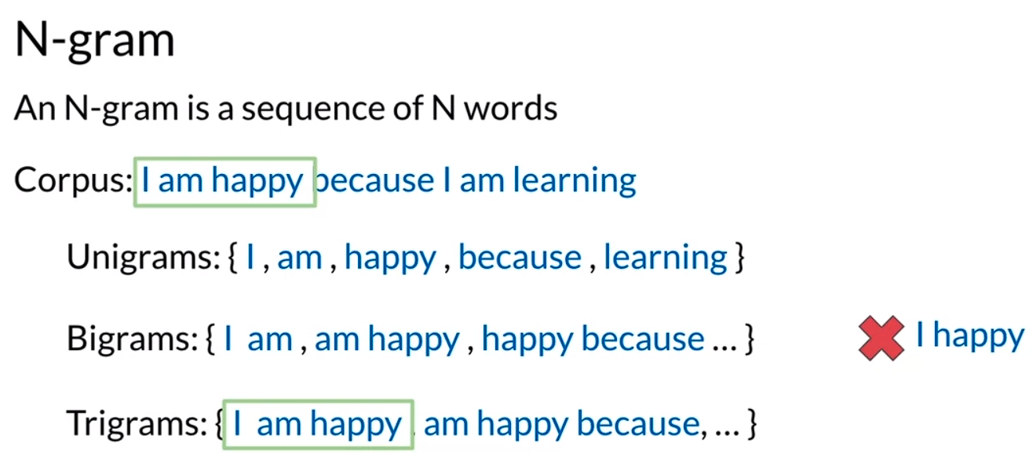

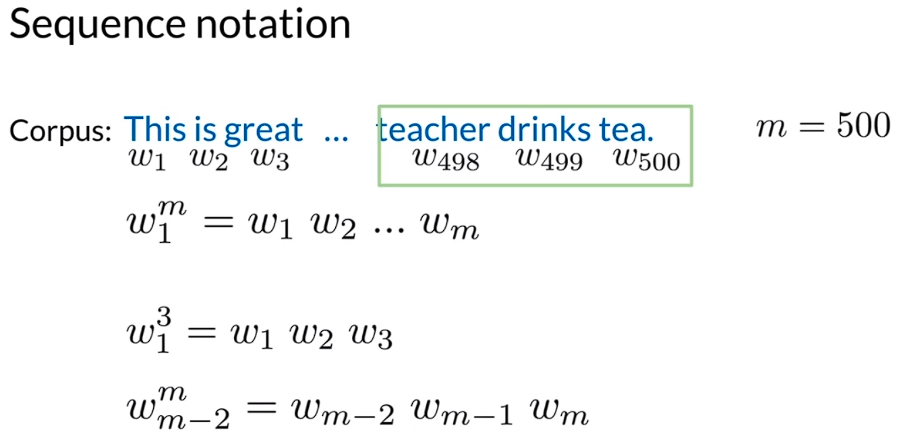

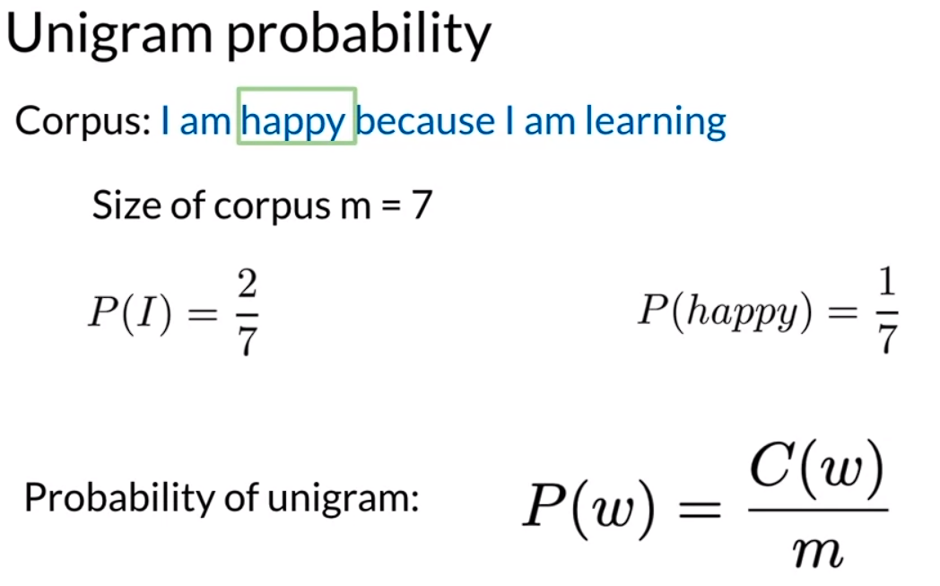

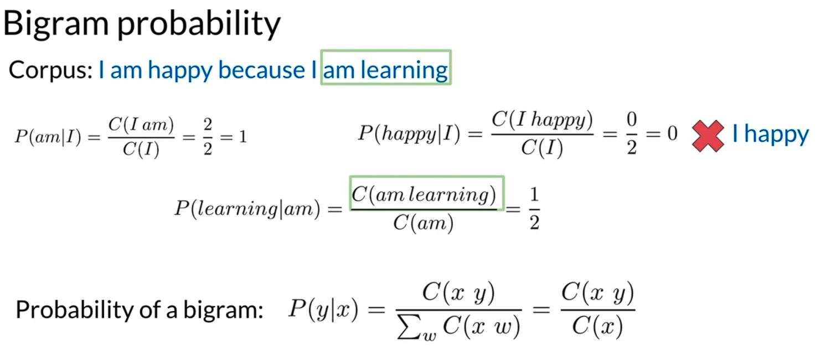

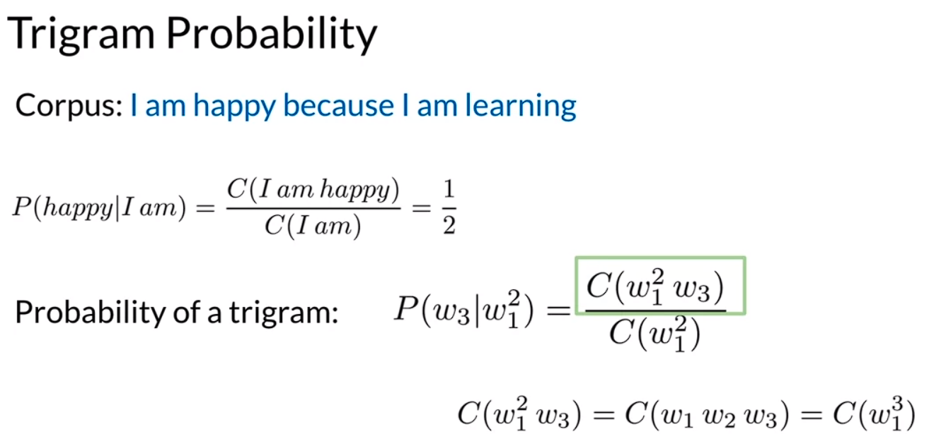

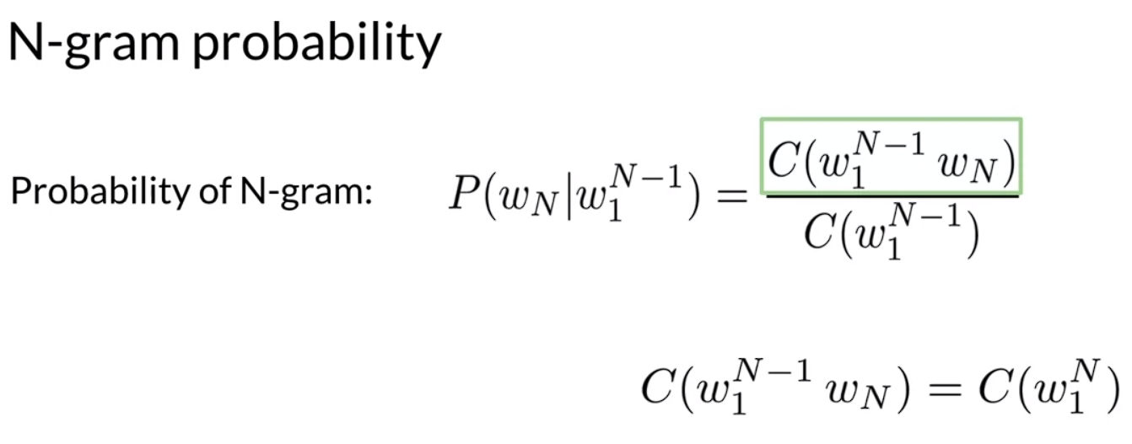

#### Sequence Probabilities

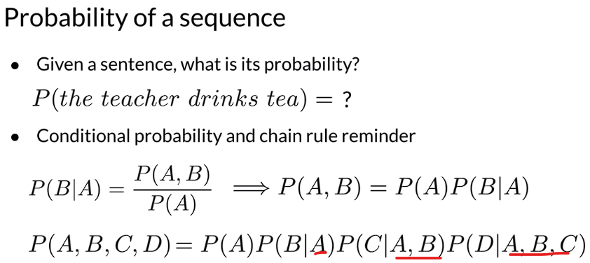

Sentence not in Corpus:

Problem: Corpus almost never contains the exact sentence we’re interested in or even its longer subsequences

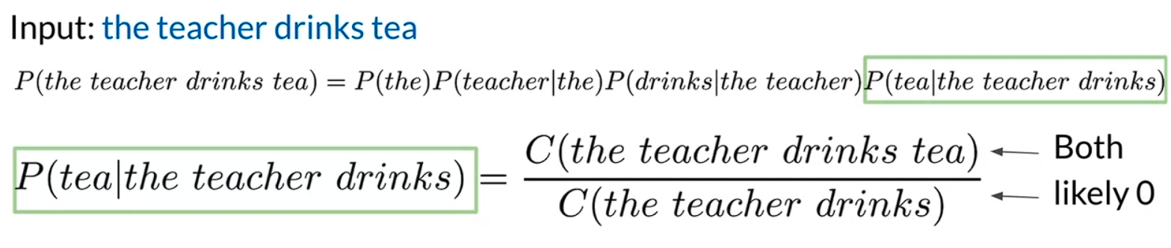

Approximation of Sequence Probability

Eg: ‘the teacher drinks tea’

$$P\left(tea\right|the teacher drinks) \sim P\left(tea \right|drinks) (Immediate words taken into account) \\ P\left(the teacher drinks tea\right)=P\left(the\right)P\left(teacher \right|the)P\left(drinks | the teacher\right)P(tea|the teacher drinks) \\ Approximated to: P\left(the\right)P(teacher|the)P(drinks|teacher)P(tea|drinks)$$

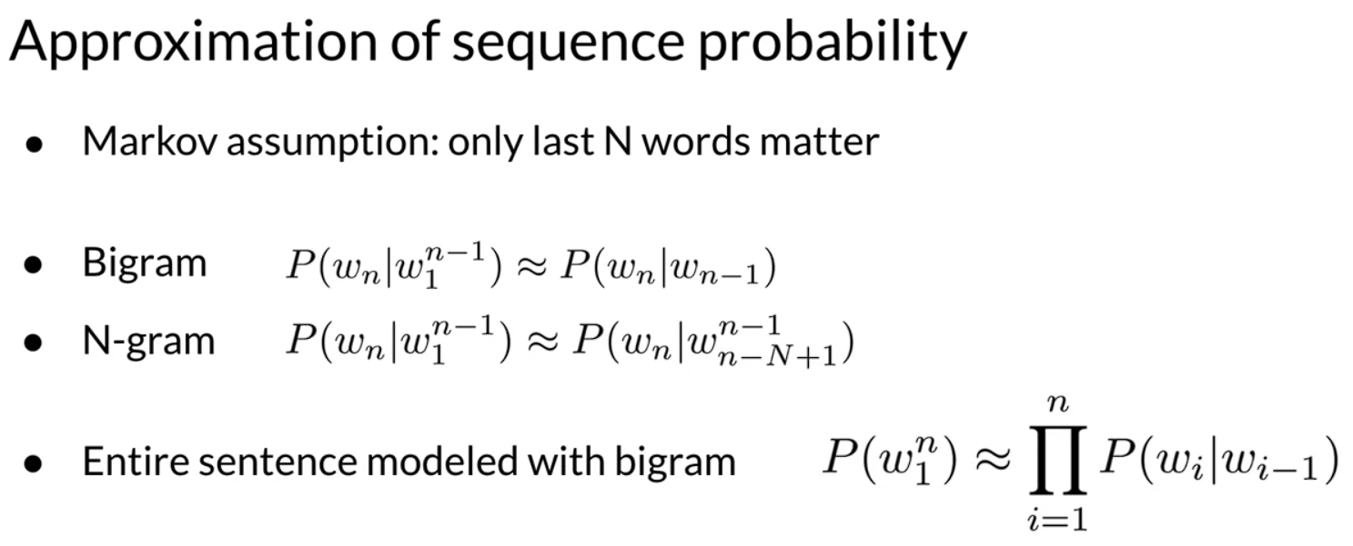

#### Starting and Ending Sentences

Start of sentence token <s> (Bi-gram)

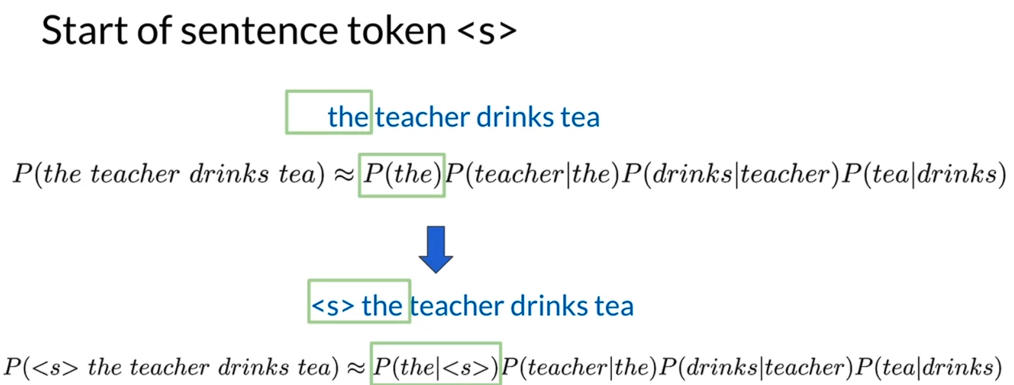

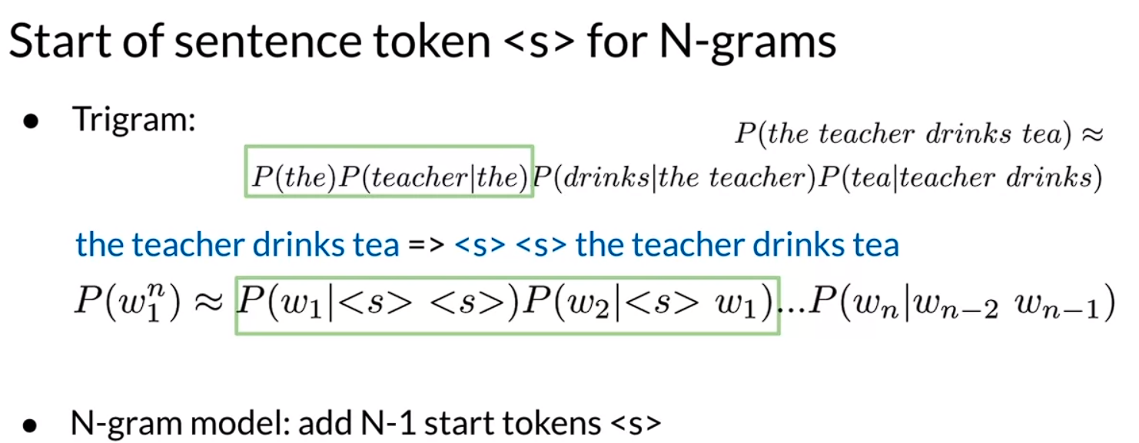

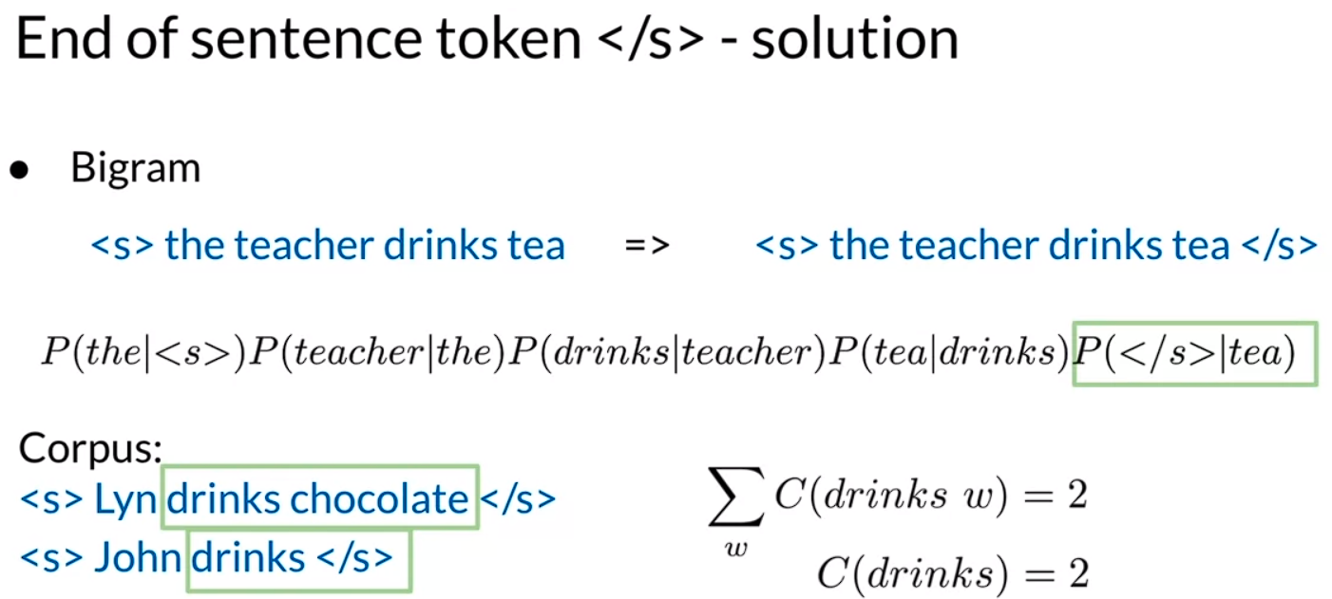

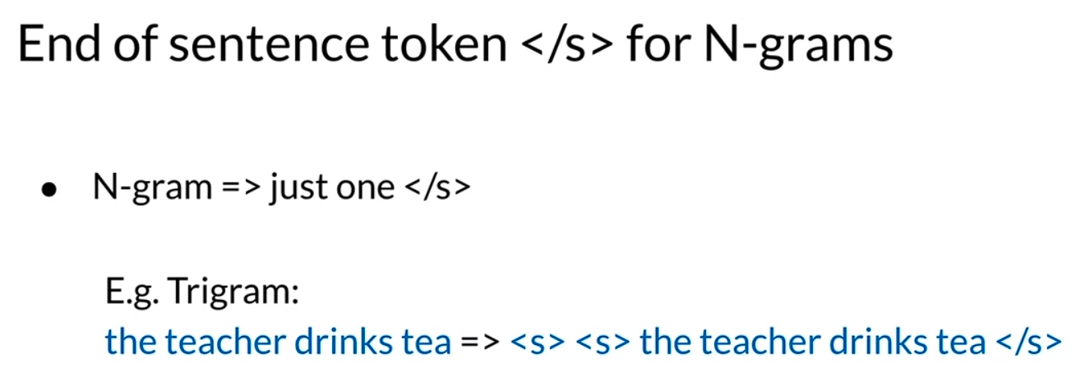

#### The N-gram Language Model

1. First, the corpus is processed into a count matrix, this captures the number of occurrences of relative n-grams
2. Transform the count matrix into a probability matrix that contains information about the conditional probability of the n-grams
3. Deal with technical issues that arise from multiplying a lots of small numbers when calculating the sentence probability
4. Use the n-gram language model to generate new sentences from scratch

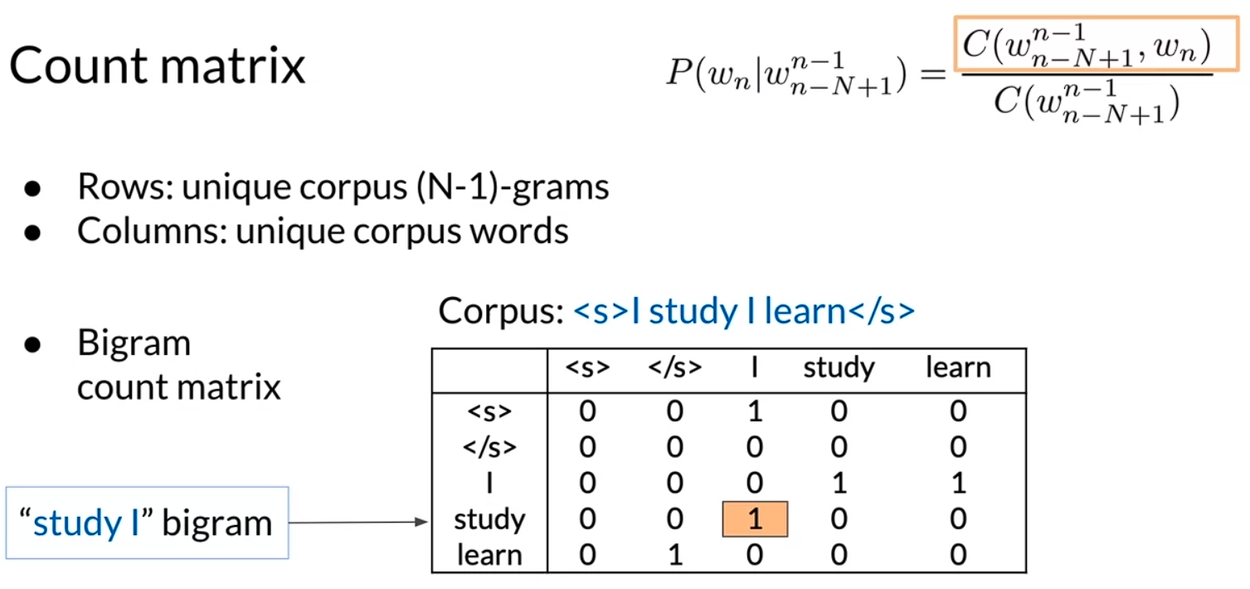

**Probability Matrix:**

* Divide each cell by its row sum.

Corpus: <s> I study I learn </s>

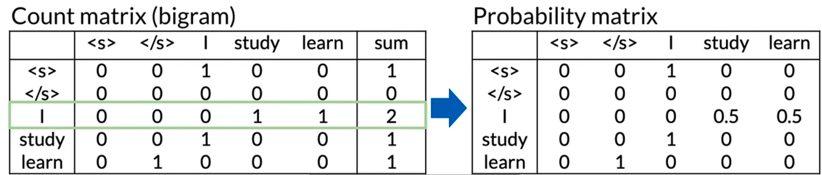

Language Model

* Probability Matrix => Language Model
  + Sentence Probability
  + Next word prediction

Generative Language Model

Corpus:

<s> Lyn drinks chocolate </s>

<s> John drinks tea </s>

<s> Lyn eats chocolate </s>

Processes:

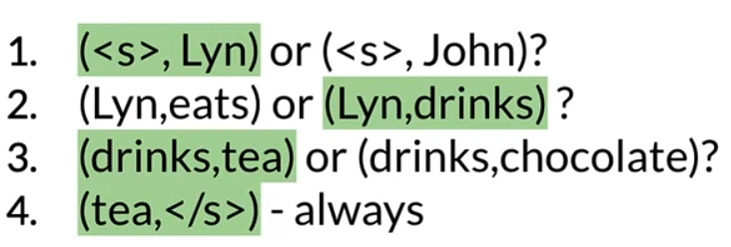

Algorithm:

1. Choose sentence start
2. Choose next bigram starting with previous word
3. Continue until </s> is picked

## Language Model Evaluation

The Perplexity Score for Language Models:

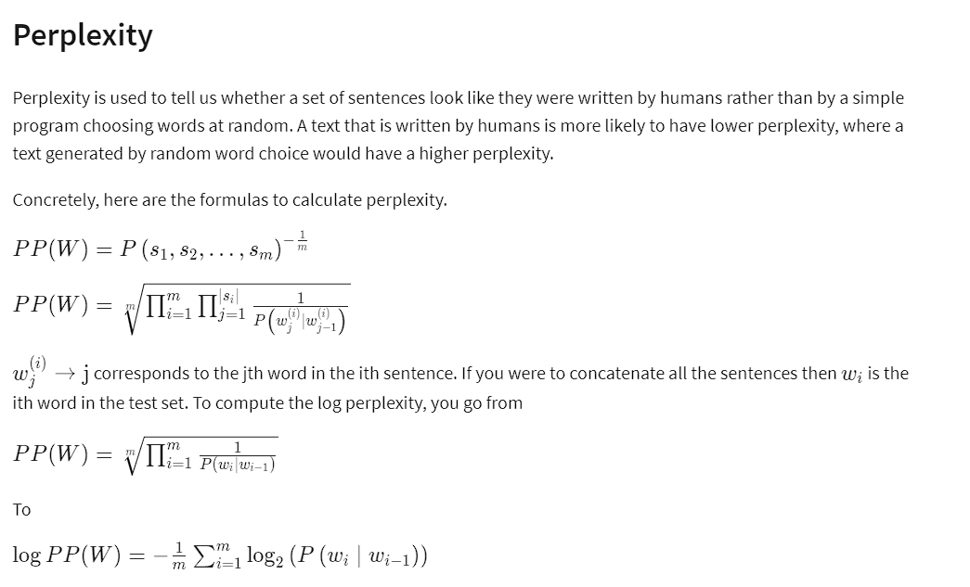

### Handling Out of Vocabulary Words (OOV)

What is a Vocabulary for Language Models?

A vocabulary is a set of unique words supported by your language model. In many tasks, you will encounter and generate words only from a fixed set of words, called closed vocabulary. Open vocabulary means that you may encounter words from outside the vocabulary, like a name of a new city in the training set.

An example:

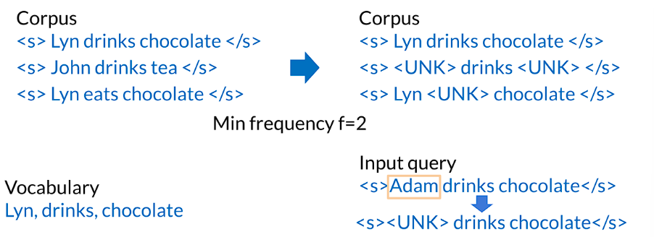

Criteria to create the Vocabulary:

1. Min word frequency f
2. Max |V|, include words by frequency
3. Use <UNK> sparingly
4. Perplexity – only compare LMs with the same V

## Dealing with missing N-grams

**Technique – 1: Smoothing (Add-1 smoothing and Add-k smoothing)**

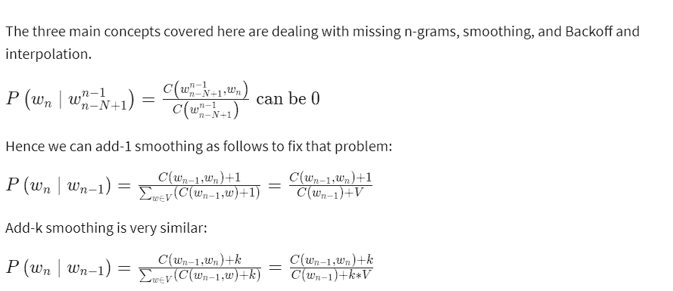

**Technique – 2: Backoff**

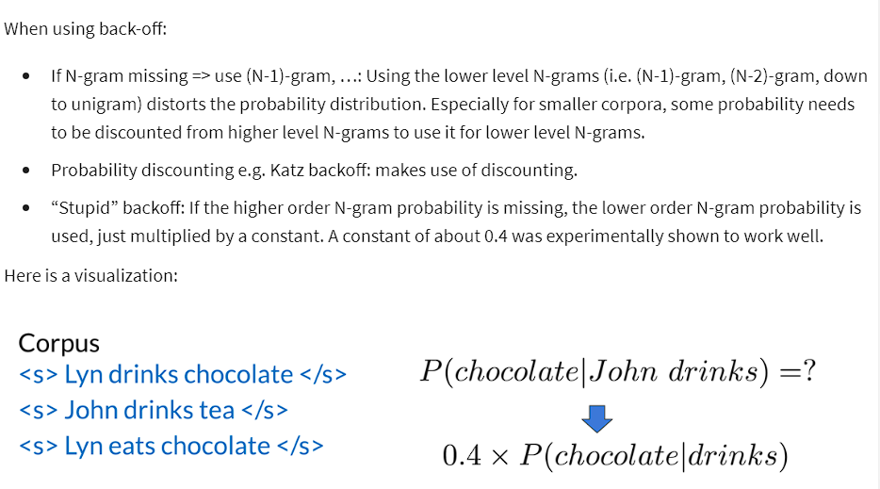

**Technique – 3: Interpolation**

